

…

…

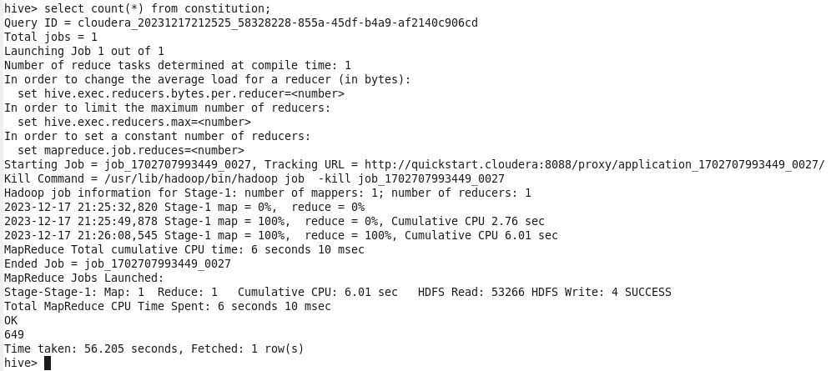

…



…

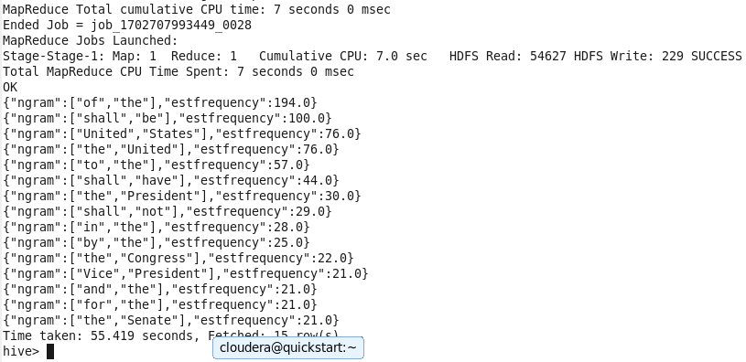

…

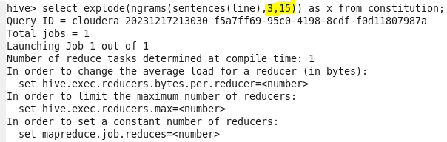

…

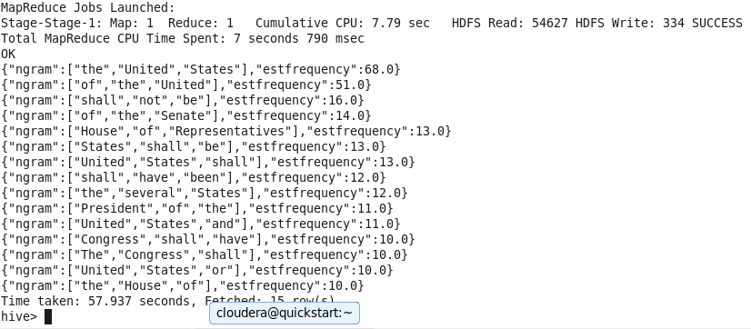

…

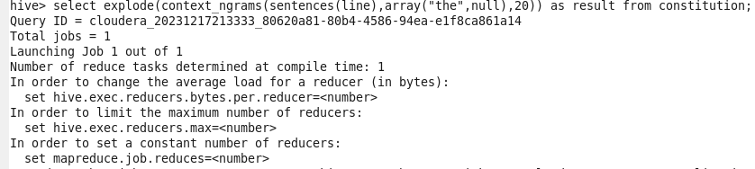

…

Top 20 bigrams after “the”

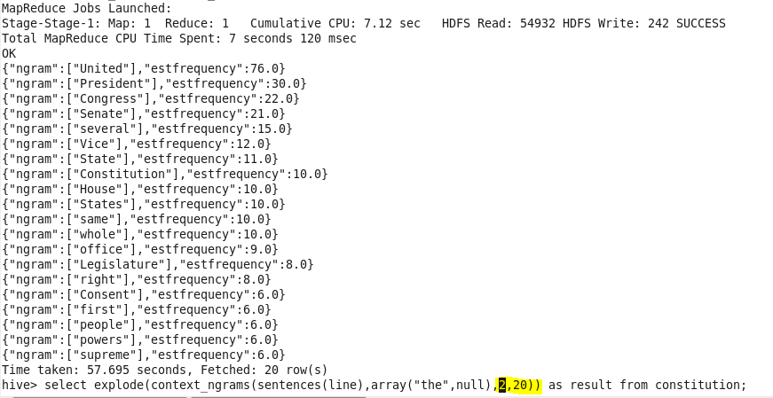

…

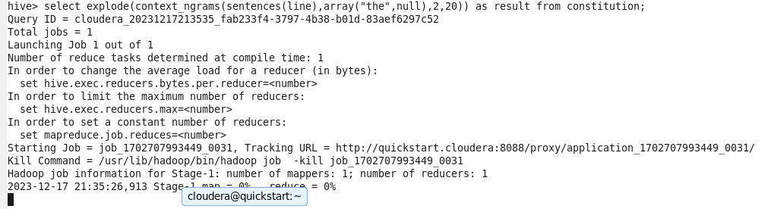

…

Top 20 words before “the”

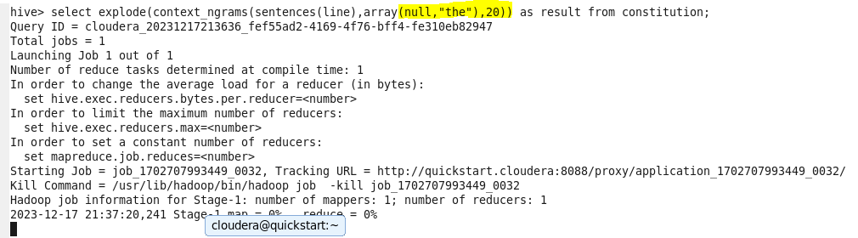

…

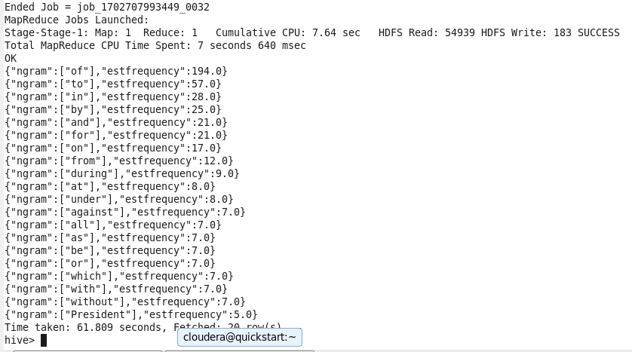

…

Top 20 words before ‘the’ and after ‘the’

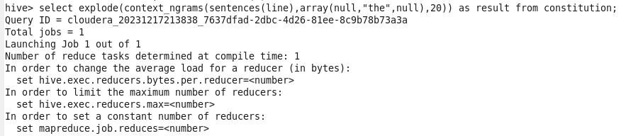

…

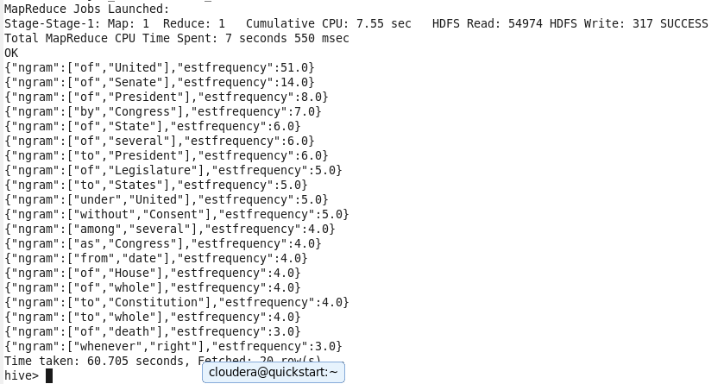

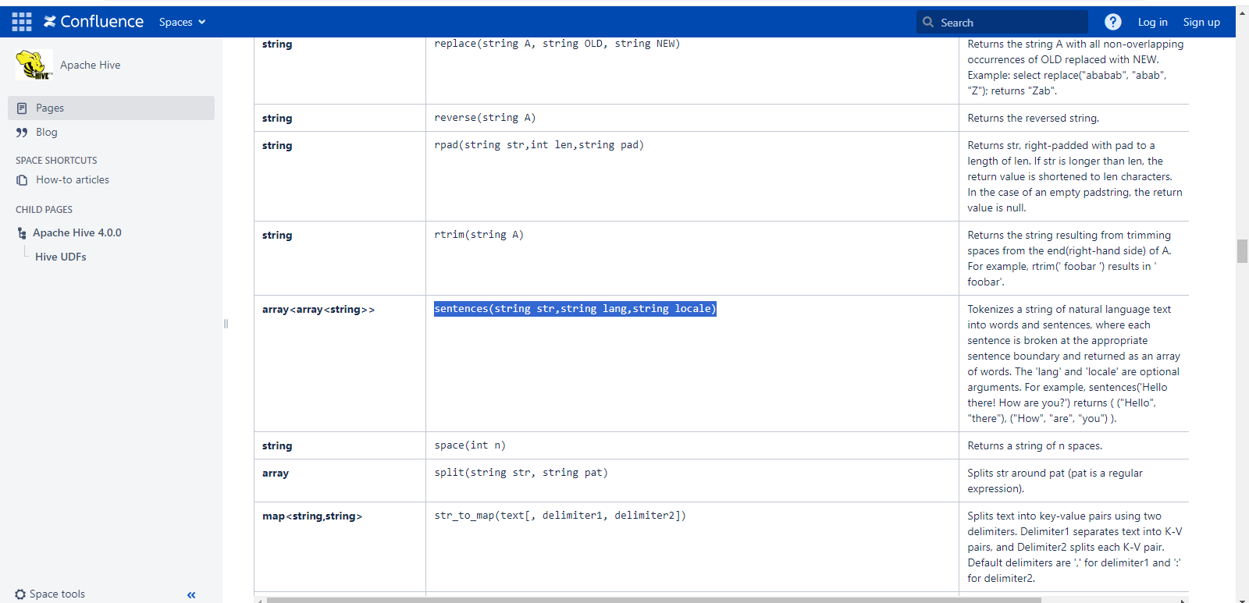

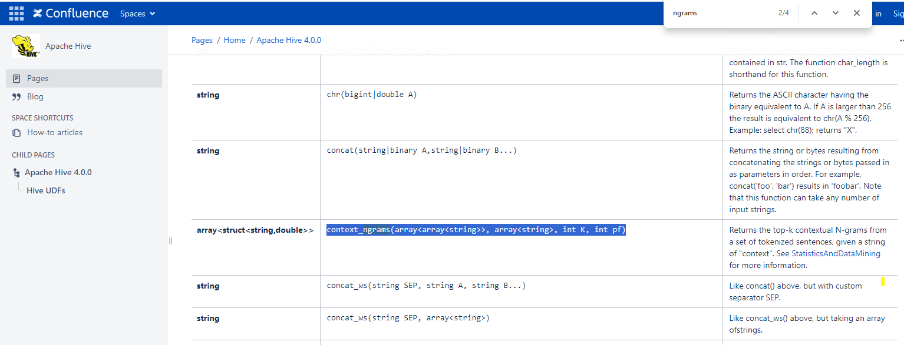

Single line o/p

Break explode the outer array and every inner array will come in single line.

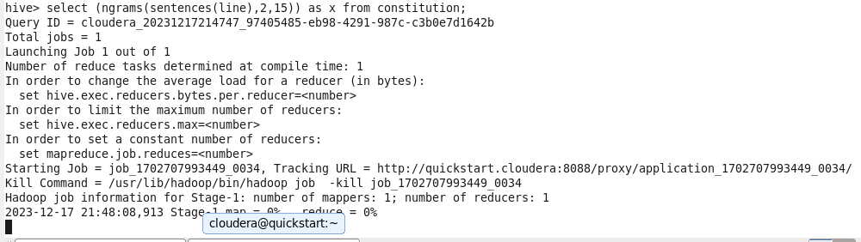

…

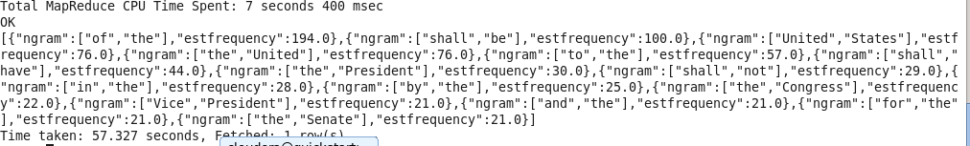

…

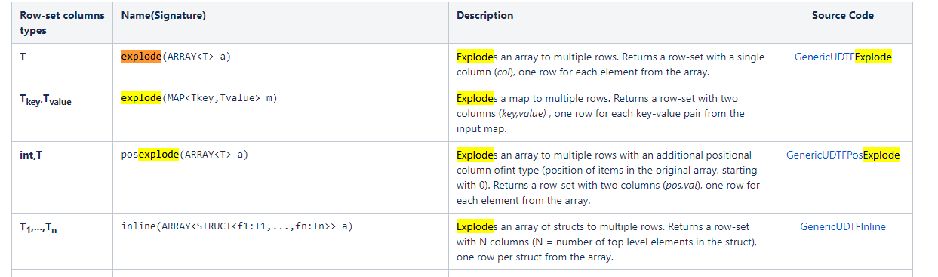

Joining data in Hive

1) Refer lab manual

2) Follow instructions in the lab manual and implement it.

Code/Dataset: data/Lab7.4.rar

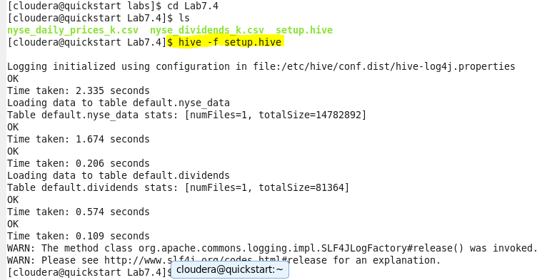

…

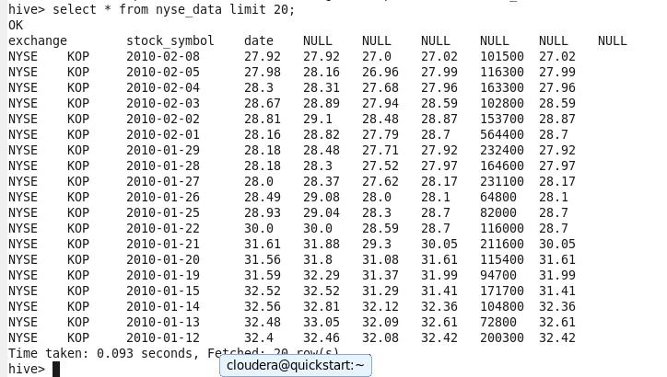

…

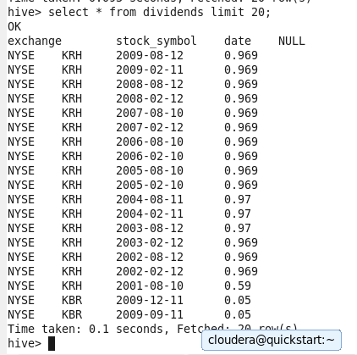

…

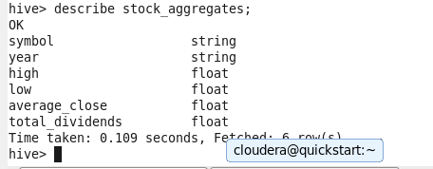

…

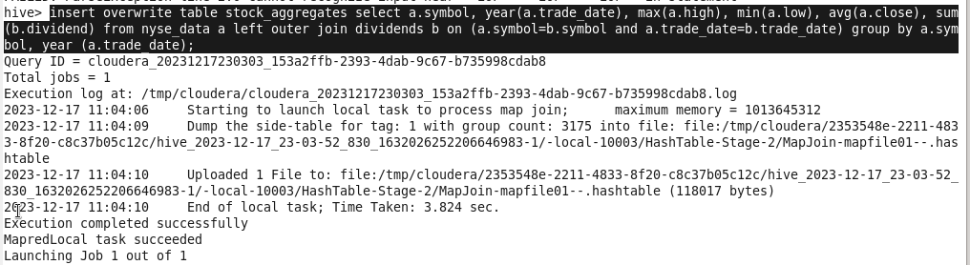

…

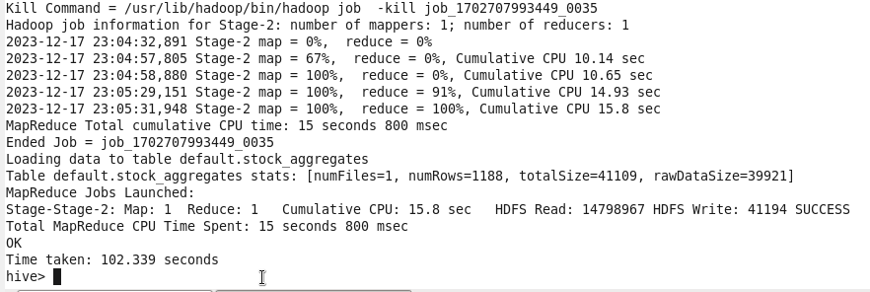

…

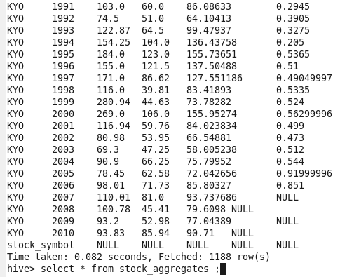

…



…

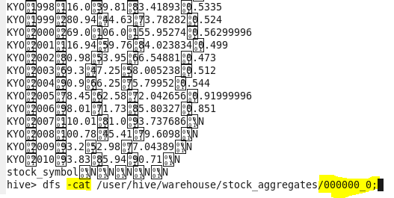

…

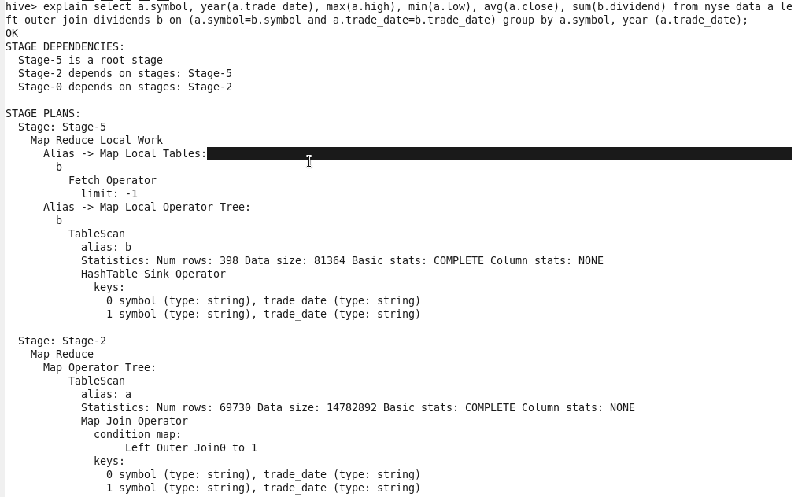

…

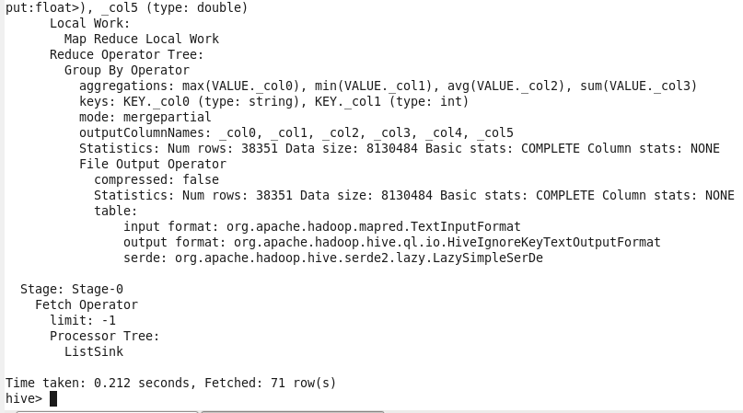

Computing ngrams of Emails in Avro Format

1) Download the rar in **STAGING_AREA**

2) Move the extracted contents to **LABS_AREA**/lab7.5

3) Refer the lab manual

4) Wait for the instructions

Code/Dataset :data/Lab7.5.rar

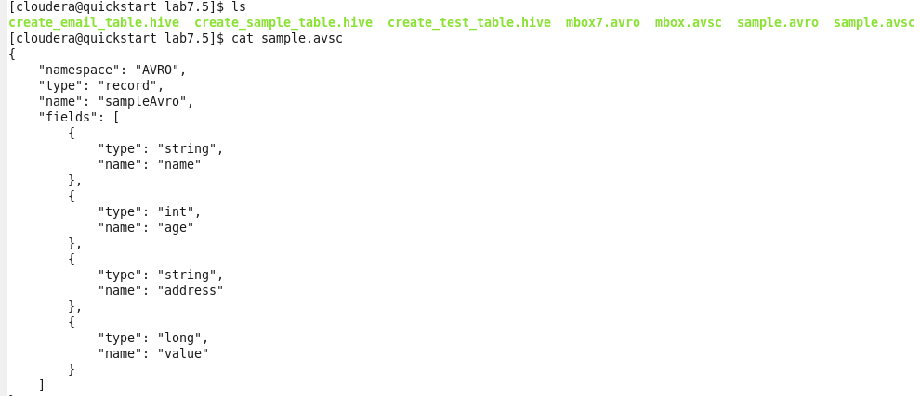

…

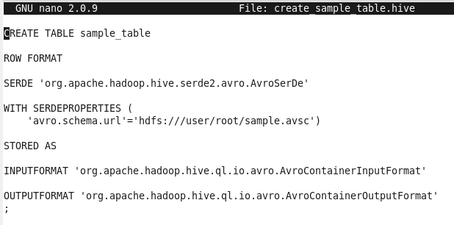

SERDE fully qualified class name,

Change path

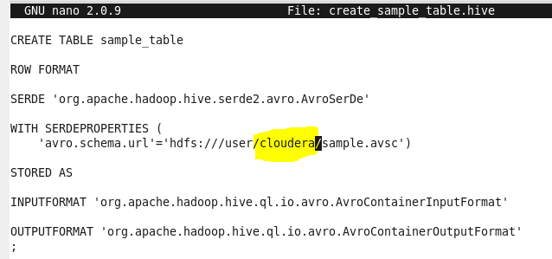

…

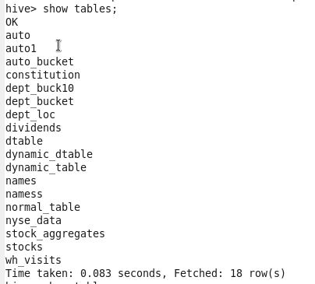

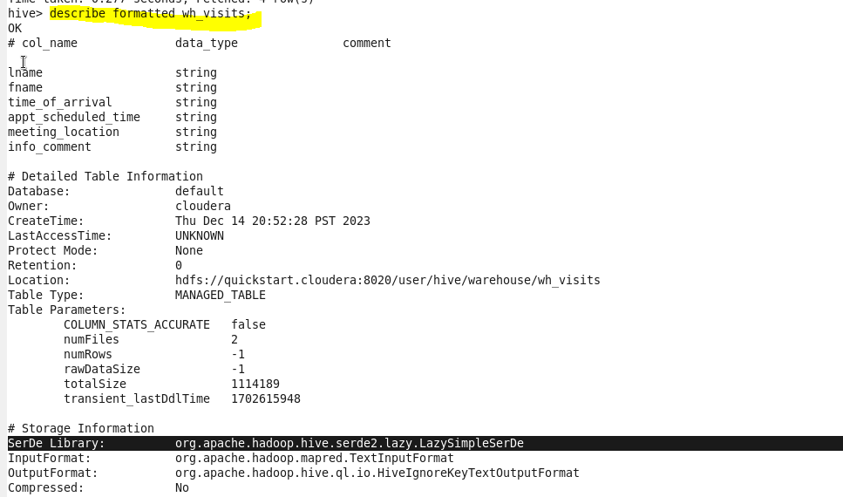

…

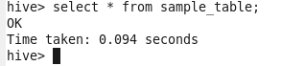

…



…

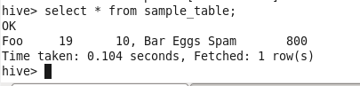

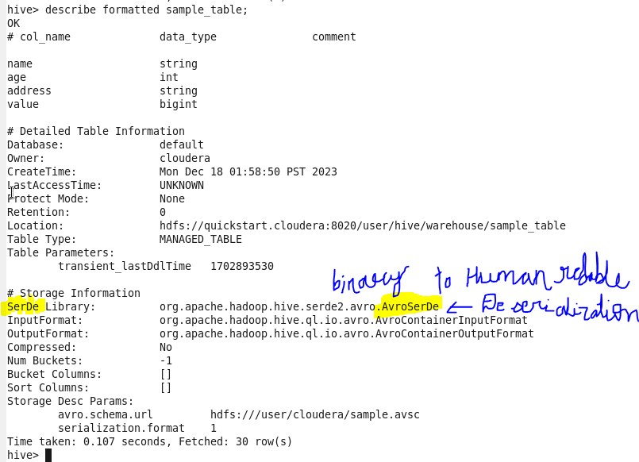

…

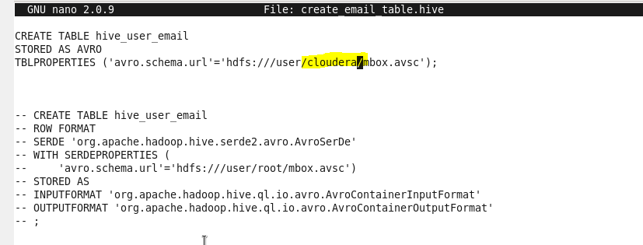

…

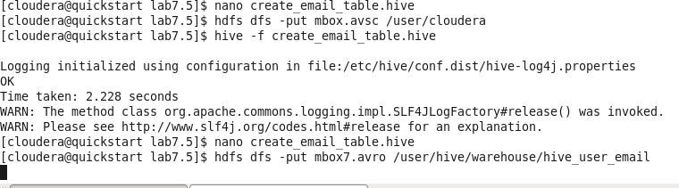

…

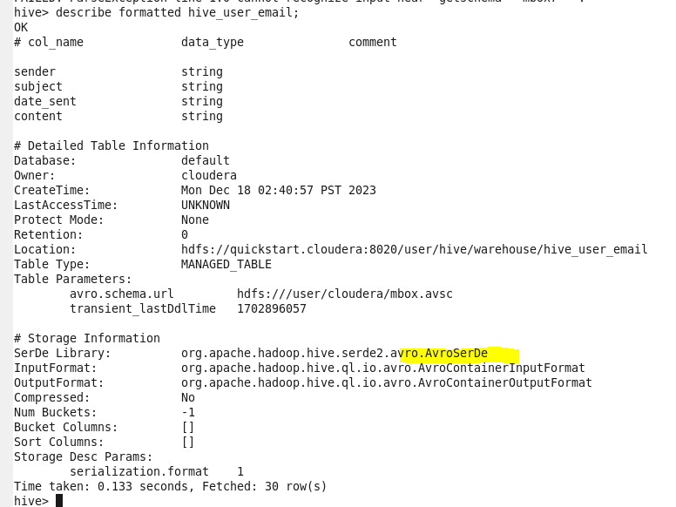

…



…

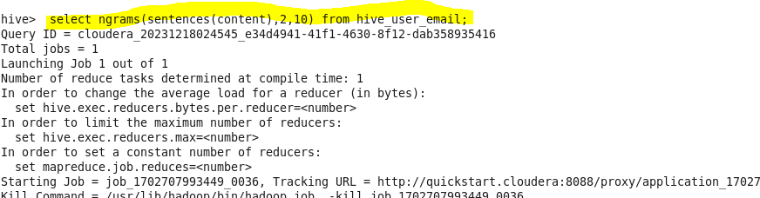

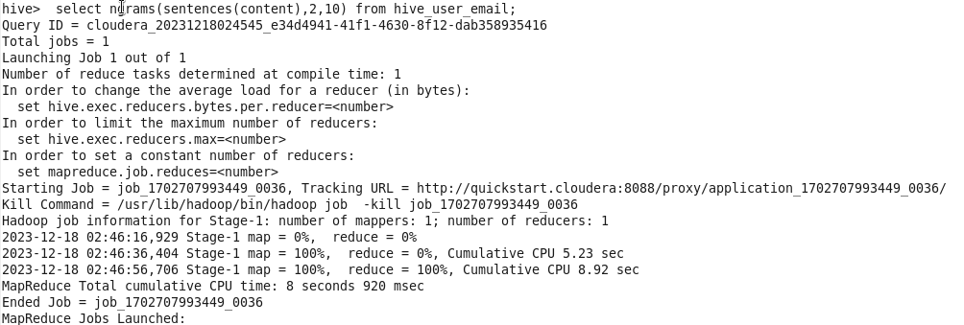

LAB- ADVANCED HIVE PROGRAMMING

9] Advanced Hive Programming

1) Download the rar on STAGING_AREA

2) Move the extracted contents to LABS_AREA/lab9.1

3) Refer the lab manual

* Code/Dataset

data/Lab9.1.rar

* TimeLine = 60 Minutes

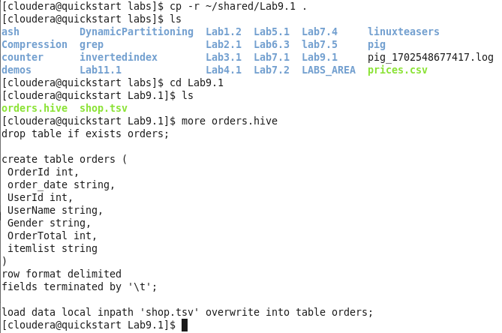

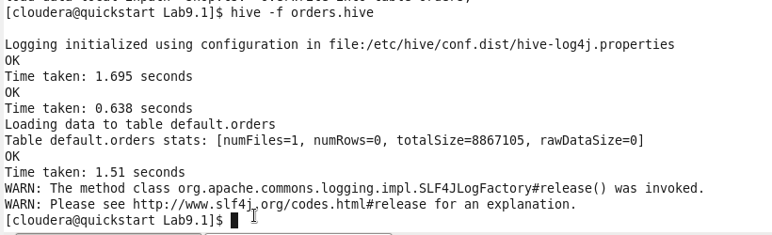

…

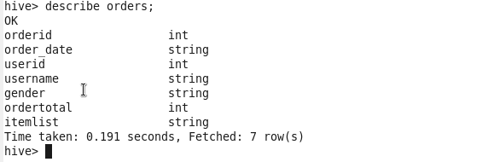

….

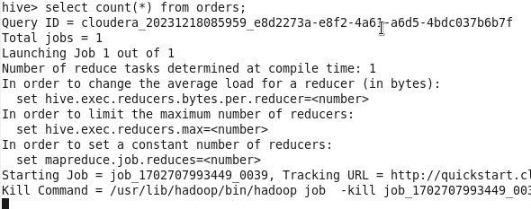

….

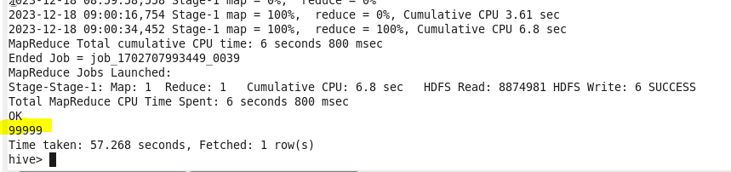

…

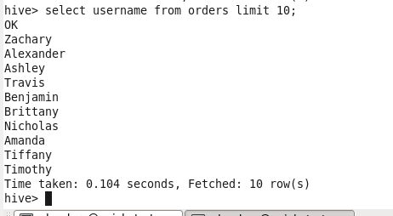

…

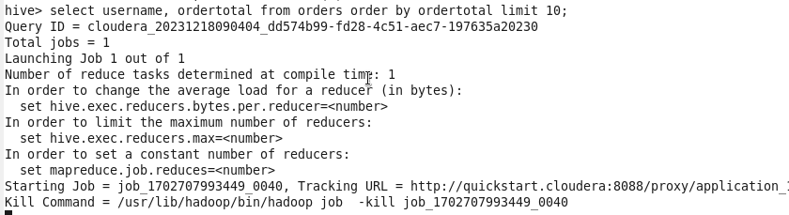

….

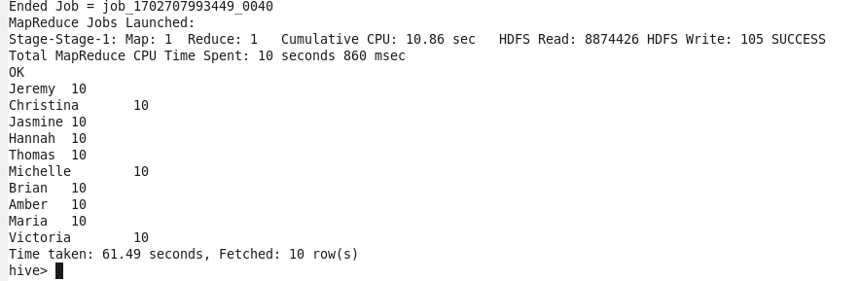

..

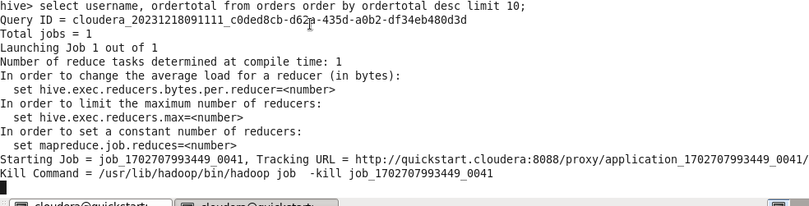

…

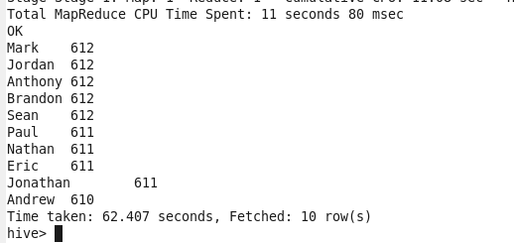

…

Lets find out if men or women spend more money.

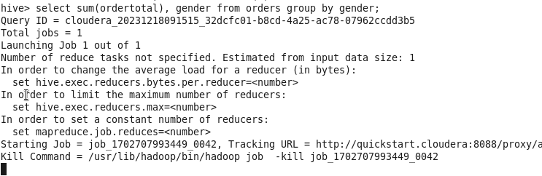

..

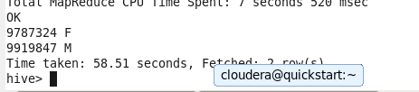

.

.

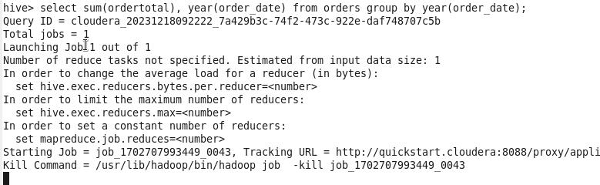

.

.

.

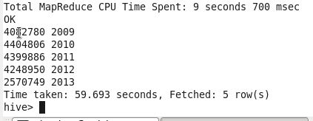

..

Create file multifile.hive in Lab9.1

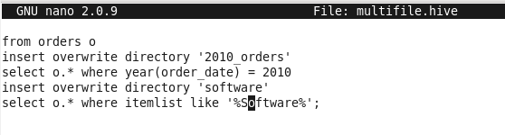..

Run the file



..

Output below

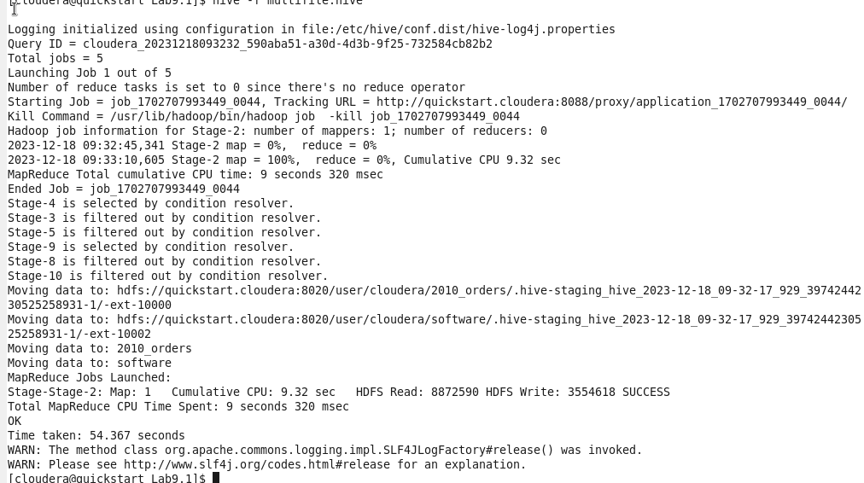

…

Check you should get two folders

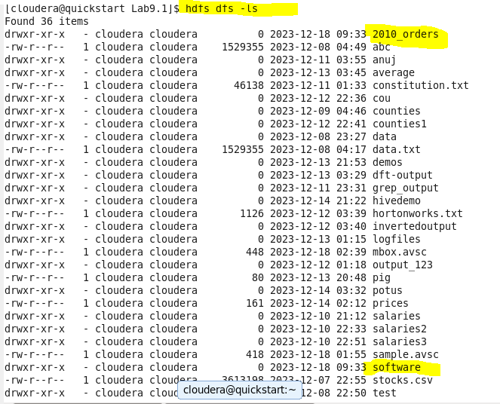

..

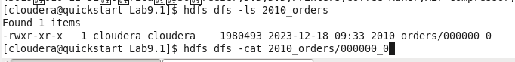

..

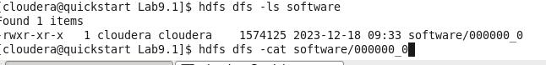

Output will not be human redable

In hive



..

You should get 2013_orders file here

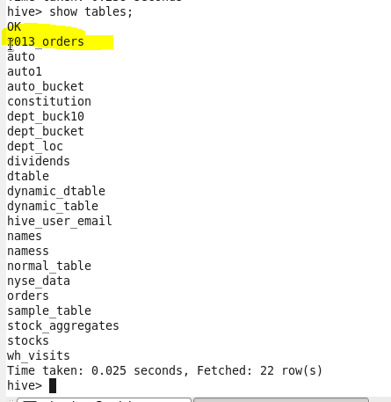

..

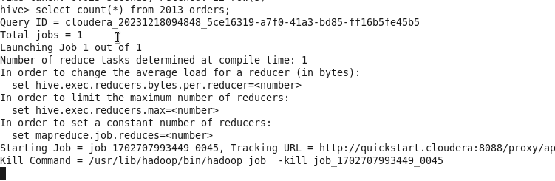

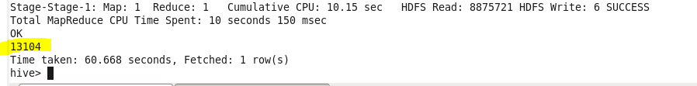

6) Find Maximum order of Each Customer

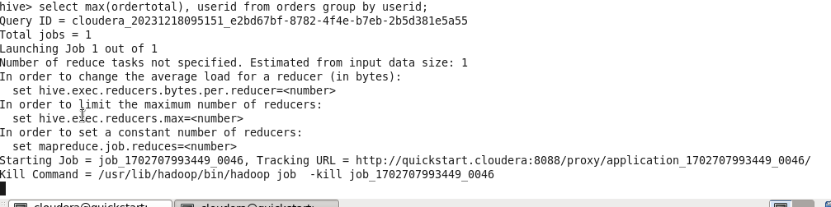

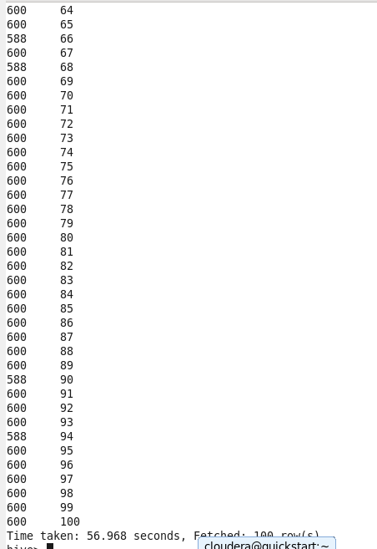

…



This querry is not valid as itemlist is not in the group by key.

..



..

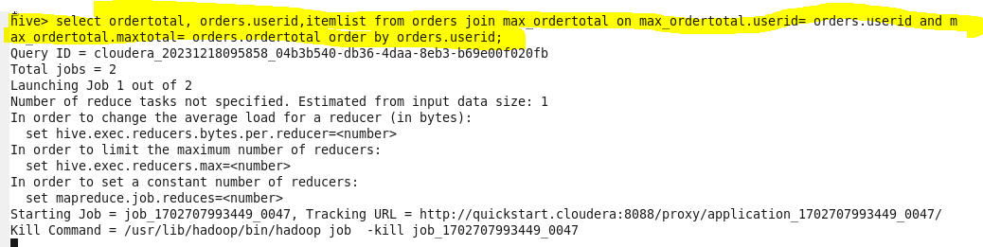

.. output

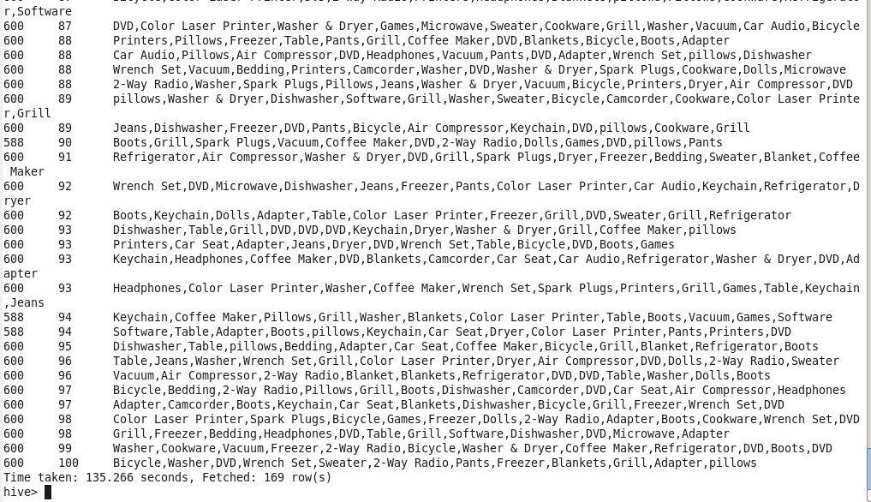

**.**

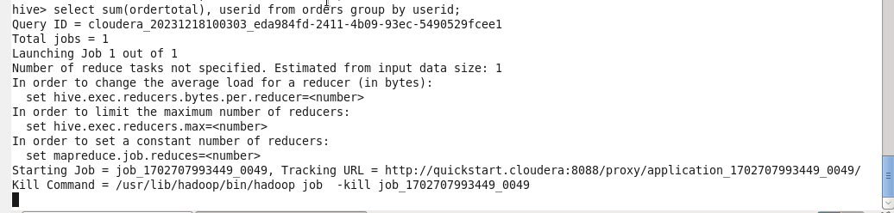

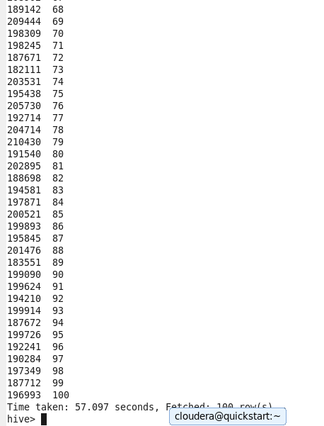

**..**

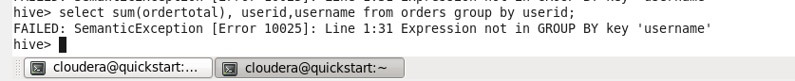

**Will give error**

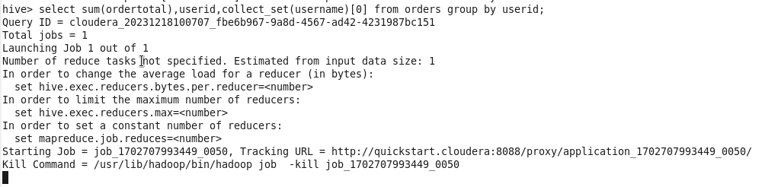

**..**

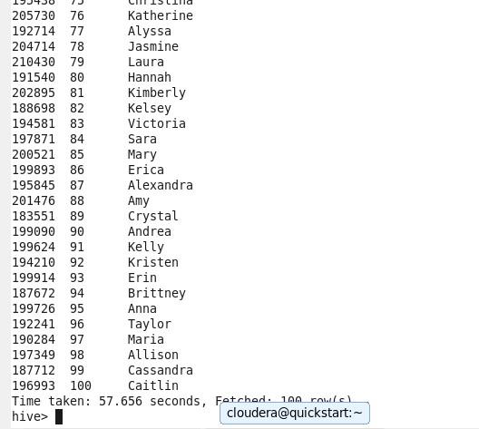

**..**

**7) using the over clause**

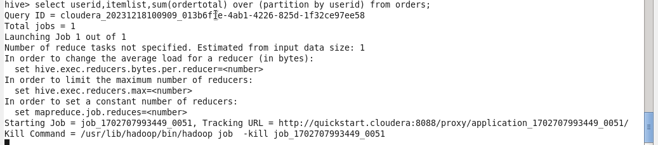

**..**

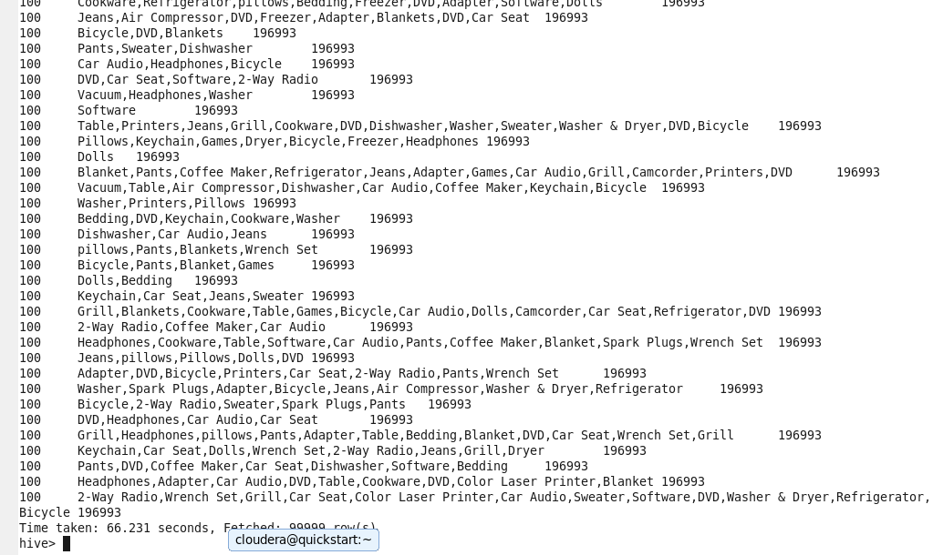

**..**

**8) Using the window Functions**

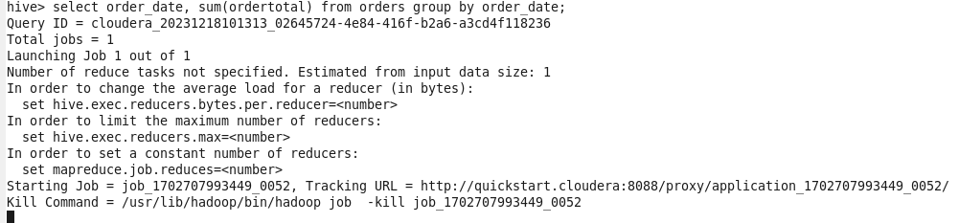

**…**

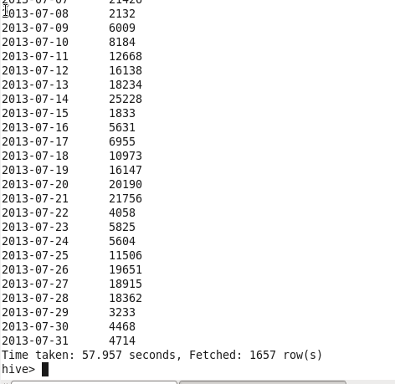

**..**

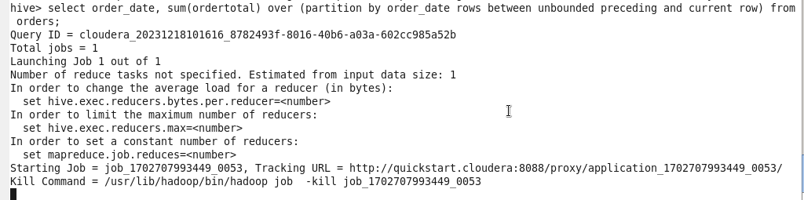

**..**

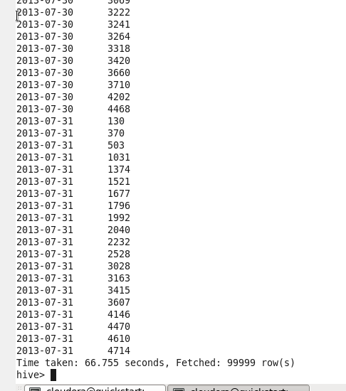

**9) Using the Hive Analytics Functions**

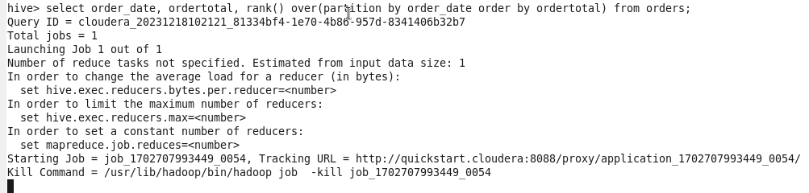

**…**

**b)**



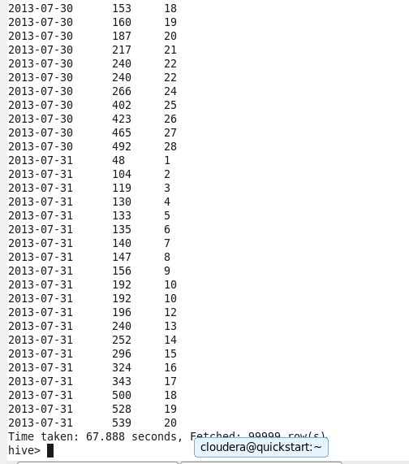

**.**

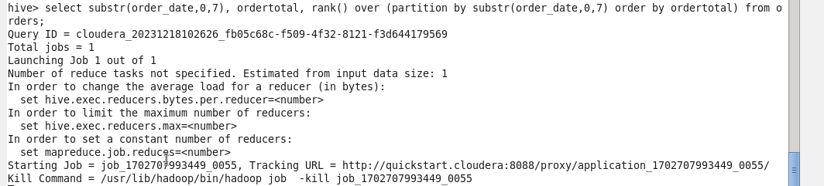

**10) Histograms**

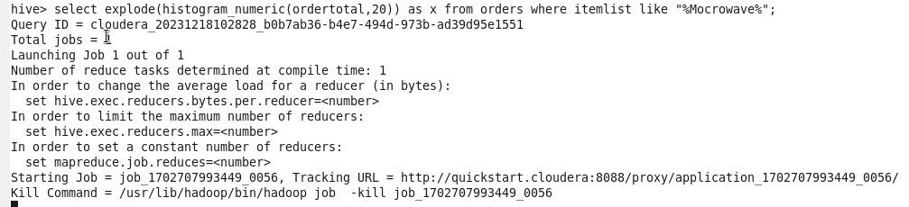

**.**

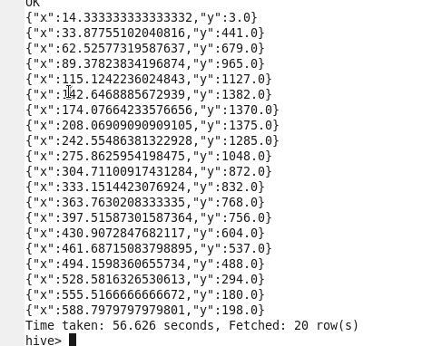

**..**

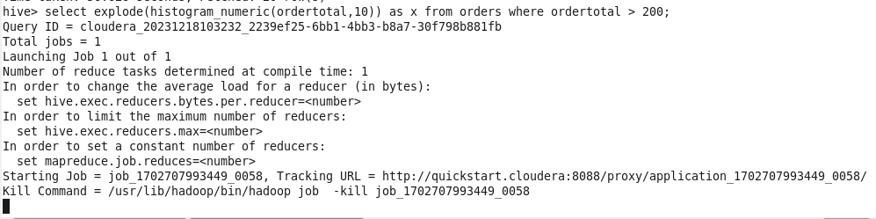

**..**

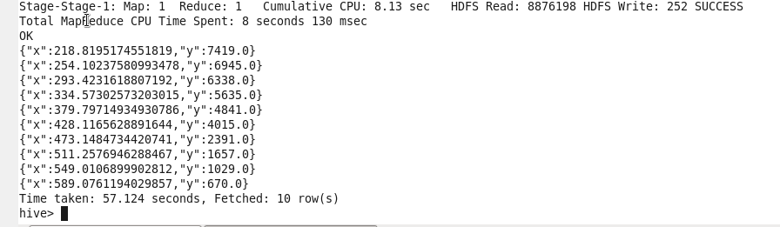

**…**

**Trying orc files**

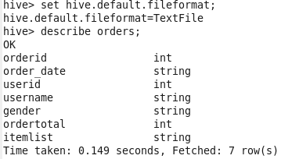

**…**



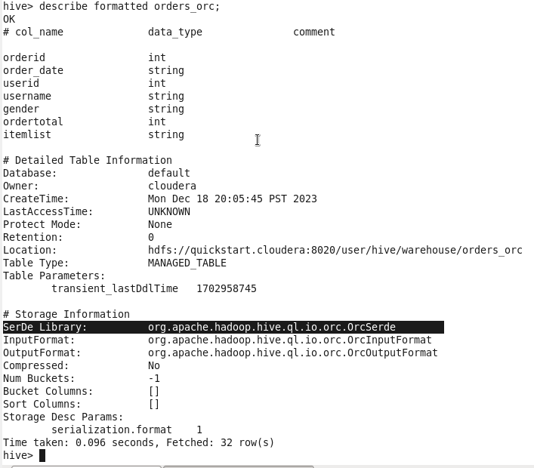

**…**

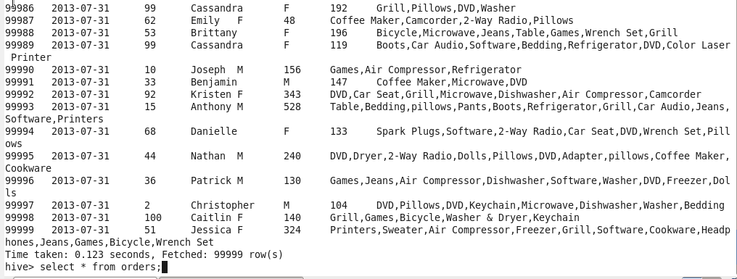

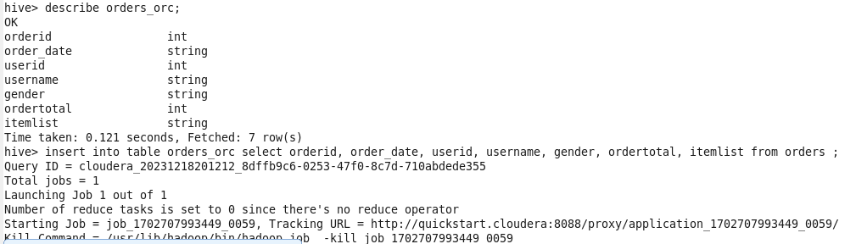

**…**

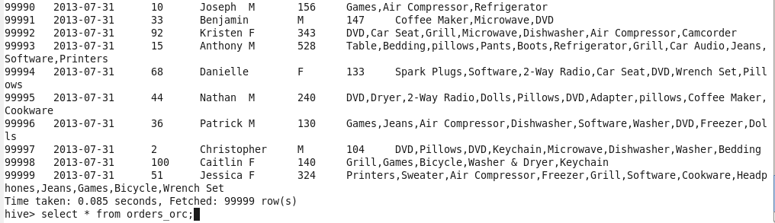

**…**

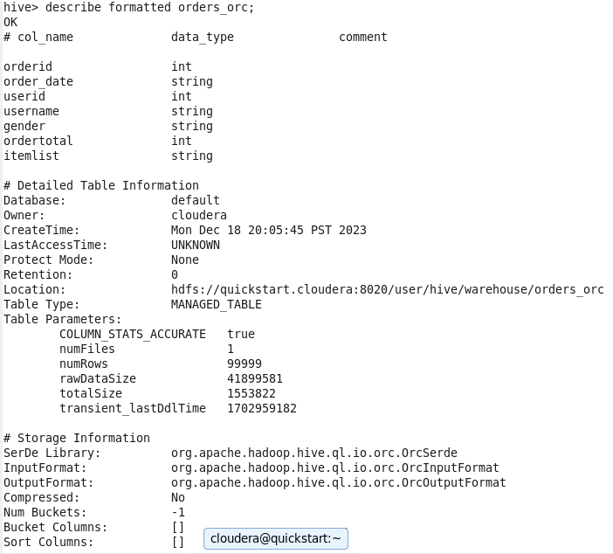

**…**

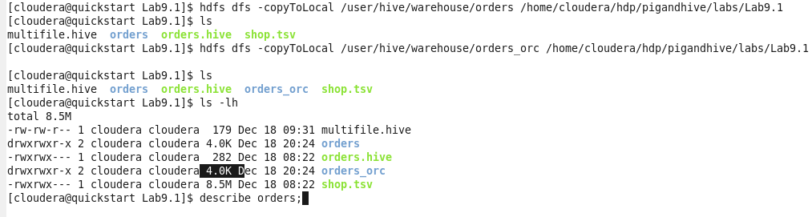

**…**

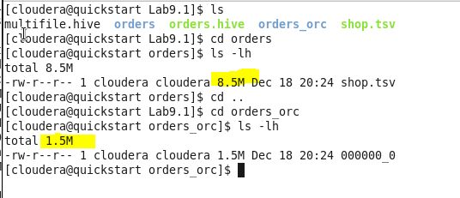

**Here orc file has less memory storage as compared to text file.**





